
COM 2610: Tips for Adding Visuals & Graphics
A visual or graphic MUST be cross referenced in a text (See Figure 1.) AND support the text in a document.
A correctly labeled visual or graphic has three (3) mandatory elements.

- a figure number under, or table number above the visual
  - A figure must be referenced in the instructions: See Figure 1.
- a complete and concise Caption after the figure number or table number
  - Figure 1. Water Heater Components
- a source so that future scholars can quote your sources in their documents (and to avoid plagiarism); unless you have created the image from original material.
  - Figure 1. Water Heater Components (Amtrol Inc.)

Correctly Labeled Visual |  | Unlabeled Visual
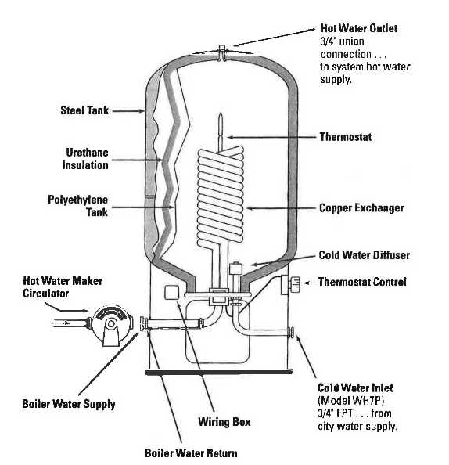
Figure 1: Water Heater Components  Source: AMTROL Inc. |  | Incorrectly used figure (without a Figure number, Caption, or Source)

OWL Purdue: Captions and Legends: For figures, make sure to include the figure number and a title with a legend and caption. These elements appear below the visual display. For the figure number, type Figure X. Then type the title of the figure in sentence case. Follow the title with a legend that explains the symbols in the figure and a caption that explains the figure:
Figure 1. How to create figures in APA style. This figure illustrates effective elements in APA style figures.

